1.created the jenkins master instance and downloaded java and open jenkins interface on tomcat.

Created the slave1 and slave2 instances that we have to connect with the master using SSH connection.

Downloaded git and java on slave1 and slave2.

Created the git repo jenkins in which there are 2 branches master and dev and each branch have respective index file.

Created the job1 and job2 which will run on slave 1 and slave2 respectively.

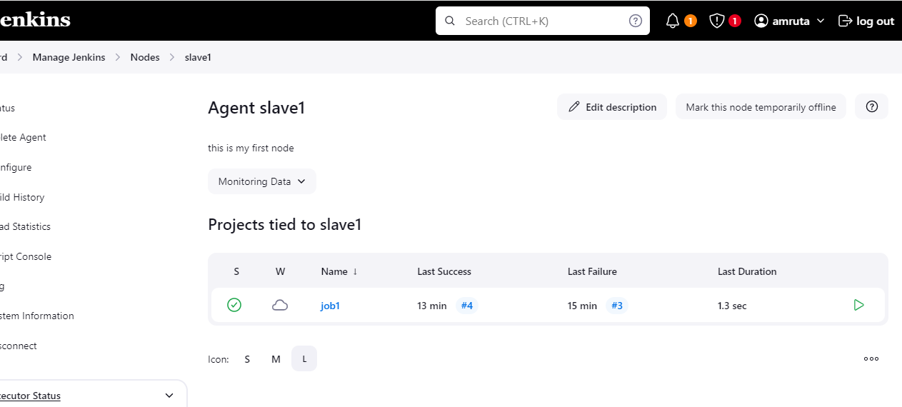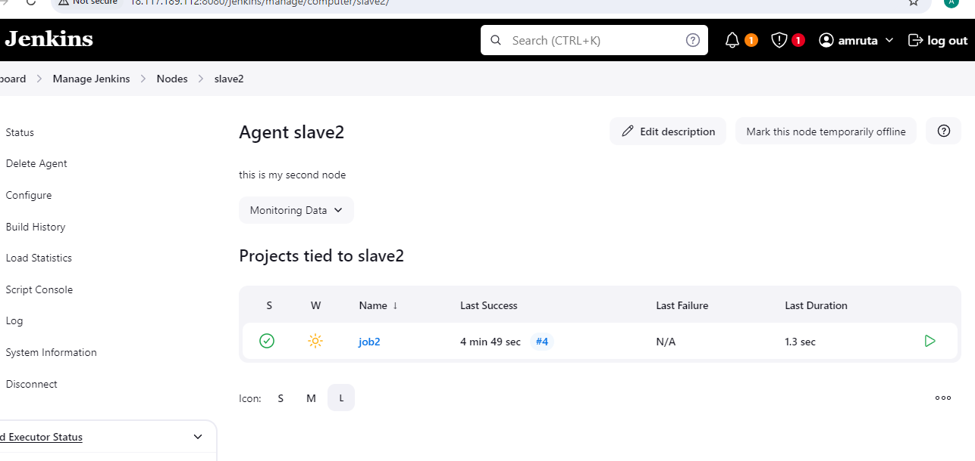created the job1 which will run on slave 1 and host the index file from branch master present in the git repo.

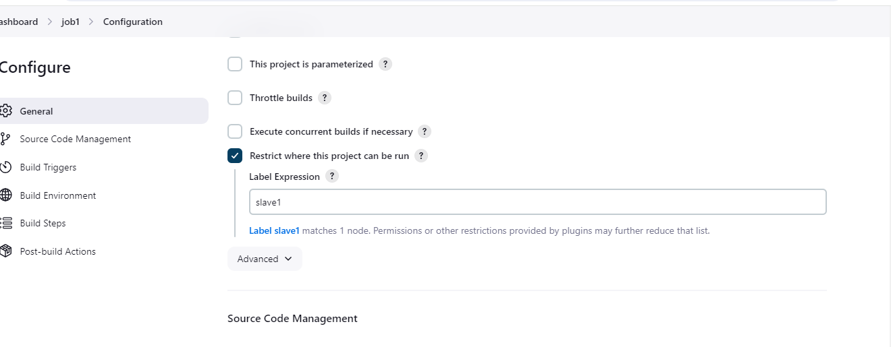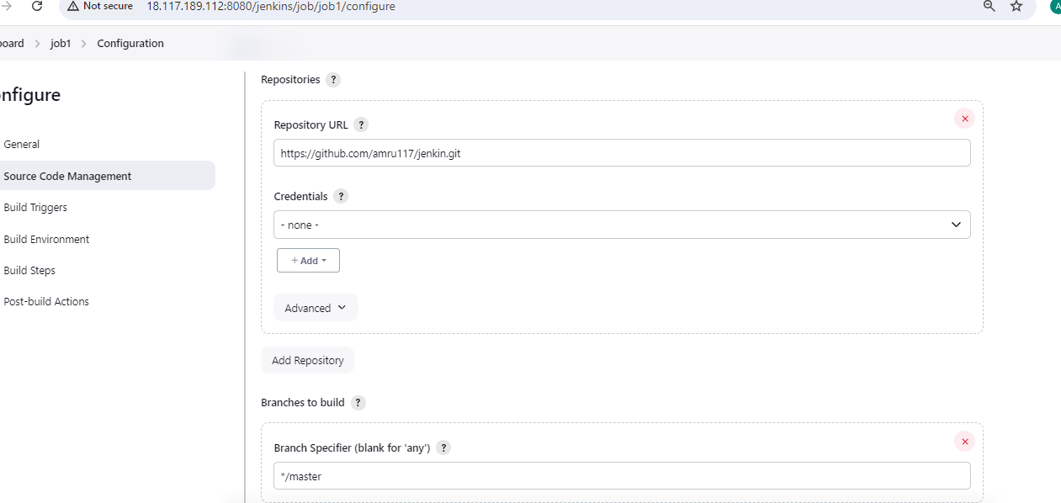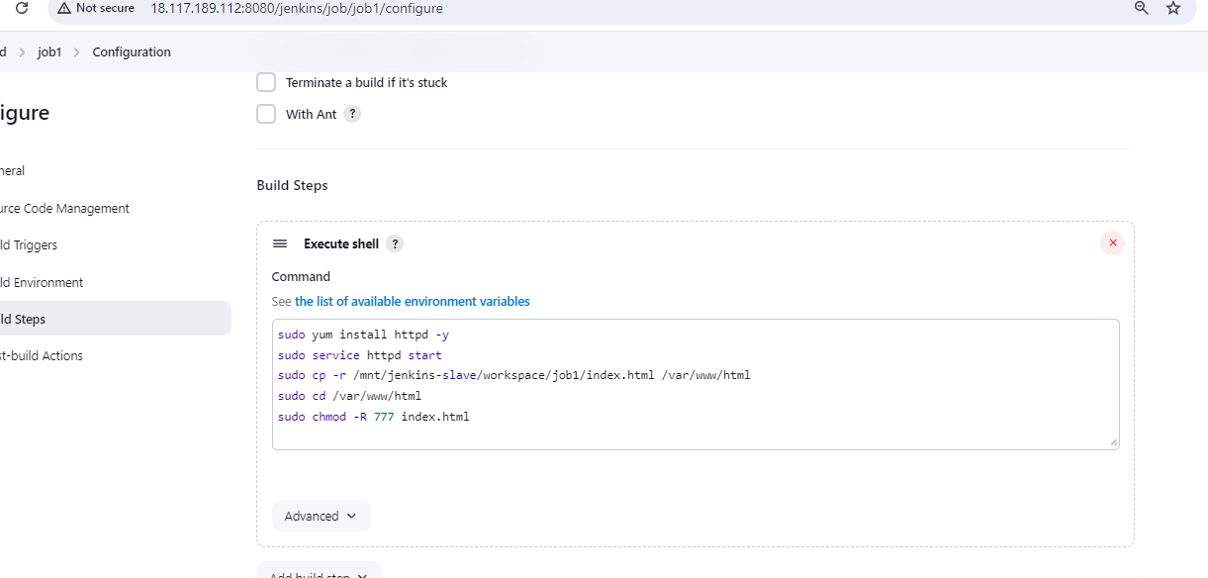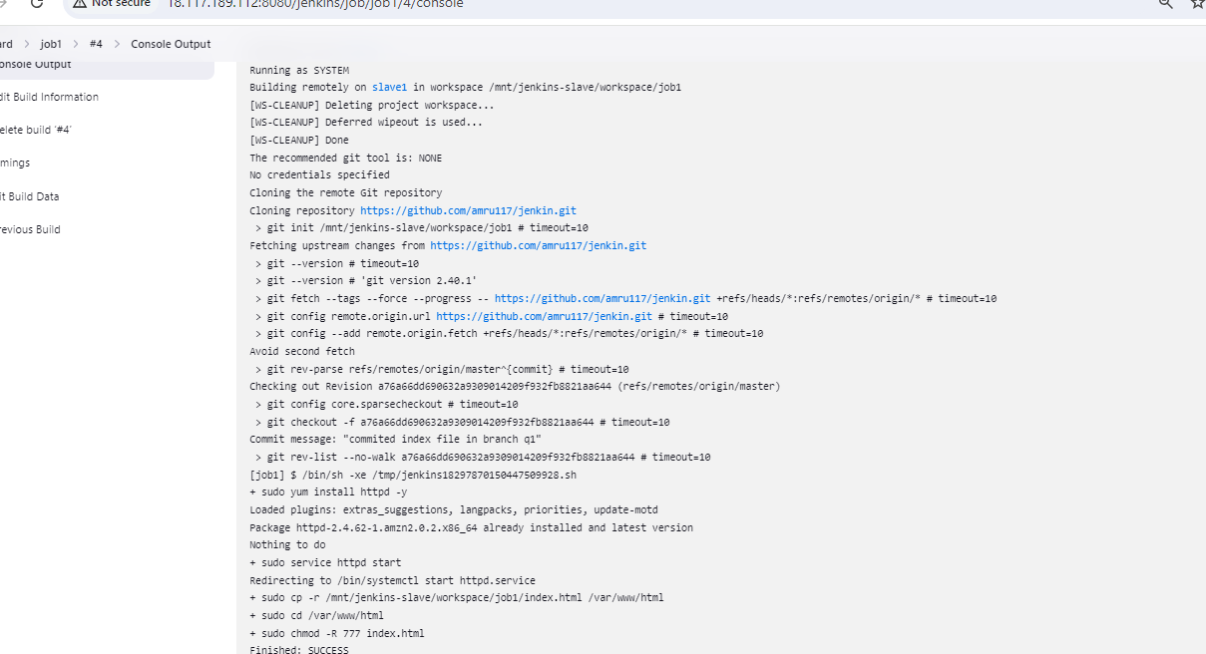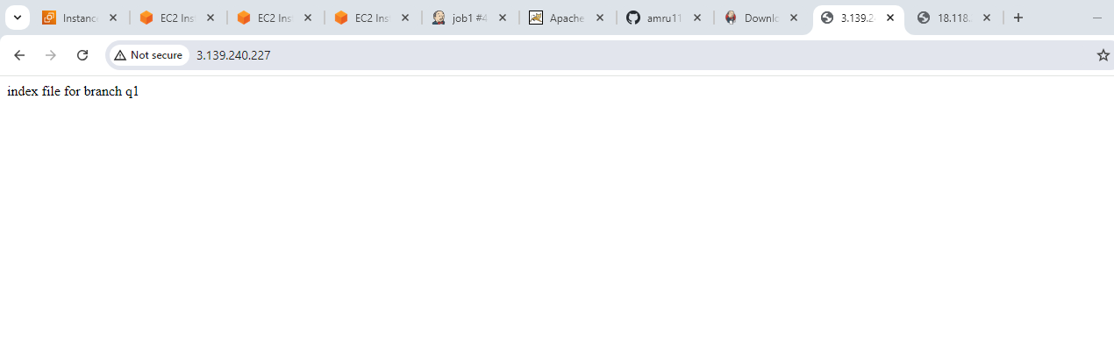created the job2 which will run on slave 2 and host the index file from the dev branch present in the jenkin repo.

